The Synnduit Dashboard can be applied to any StarBridge database. We currently have 8 production ones.
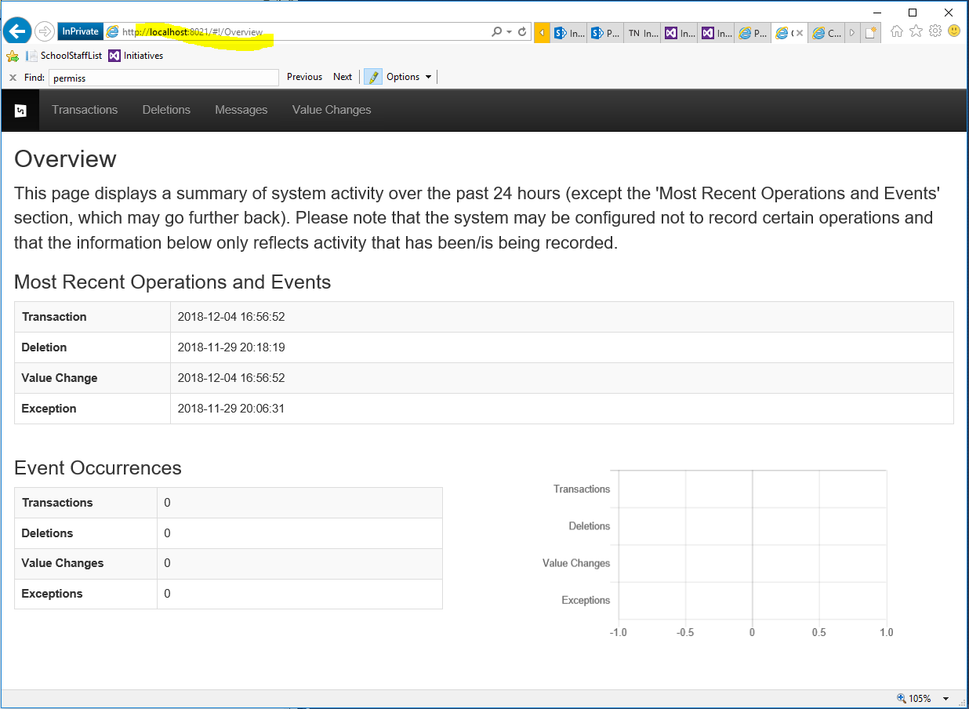
For older StarBridge databases, the process requires copying the StarBridge database in question over to a local machine. Check the list of views using SSMS; if there are a lot of Console views, you are good. If not, run 2 scripts found in Dev-ops:
C:\Repos\SynnduitDashboard\
Along with an instructional doc to set things up locally:
C:\Repos\SynnduitDashboard\Setting up the Starbridge Dashboard.docx

